Module 2 Assignment:

Question 1:

List the copyright year and title for each compact disc (CD), in descending order by copyright year.

SQL statement:

SELECT CD_TITLE, COPYRIGHT_YEAR

FROM music_inventory.COMPACT_DISCS

ORDER BY COPYRIGHT_YEAR DESC;

Result Screenshot:

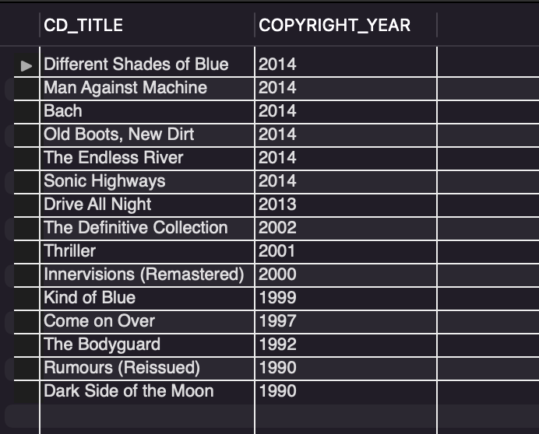

Question 2:

List the CD ID and title for CDs copyrighted in 2014 that also have an in-stock inventory over 20.

SQL statement:

SELECT CD_ID, CD_TITLE

FROM music_inventory.COMPACT_DISCS

WHERE COPYRIGHT_YEAR = 2014 AND IN_STOCK > 20;

Result Screenshot:

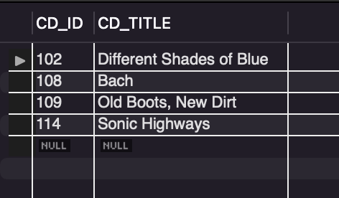

Question 3:

List each copyright year along with the number of titles and the total quantity in-stock for the compact discs copyrighted that year.

SQL Statement:

SELECT COPYRIGHT_YEAR, COUNT(CD_TITLE) AS TITLE_NO, SUM(IN_STOCK) AS STOCK_QUANTITY FROM music_inventory.COMPACT_DISCS

GROUP BY COPYRIGHT_YEAR;

Result Screenshot:

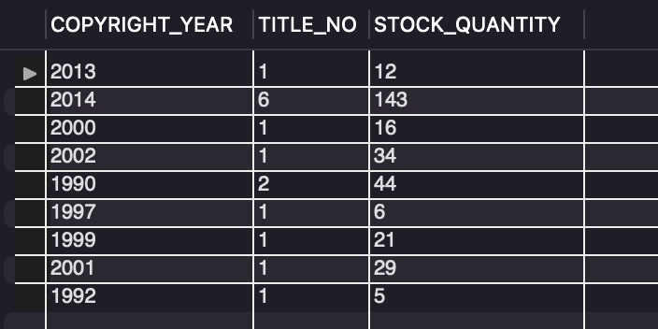

Question 4:

List the CD ID and title of CDs that have an in-stock quantity that is higher than the average in-stock quantity for all CDs.

SQL statement:

SELECT CD_ID, CD_TITLE FROM music_inventory.COMPACT_DISCS

WHERE IN_STOCK > (SELECT AVG(IN_STOCK) FROM music_inventory.COMPACT_DISCS);

Result Screenshot:

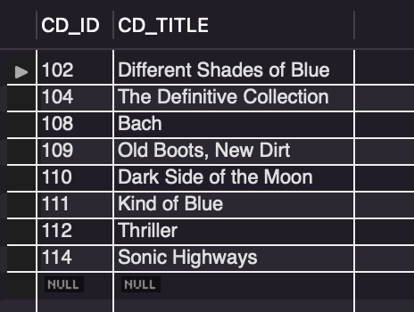

Question 5:

List the CD ID and title of all CDs where Stevie Wonder is an artist.

SQL statement:

SELECT A.CD_ID, C.CD_TITLE FROM ARTIST_CDS A

JOIN ARTISTS B

ON A.ARTIST_ID = B.ARTIST_ID

JOIN COMPACT_DISCS C

ON A.CD_ID = C.CD_ID

WHERE B.ARTIST_NAME = "Stevie Wonder";

Result Screenshot

